**Qashan Palestinian Culture Products**

Web programming class project, acadimec year 2024 /2025

|  |  |  |  |  |
| --- | --- | --- | --- | --- |
| Student Name in English | Student Name in Arabic | Student ID | Section time as shown in zajel | Work percentage |
| Omar Alaa Jarbou | عمر علاء جربوع | 12112067 | 8-9:30 | 50% |
| Karam Zaidan | كرم زيدان | 12112080 | 8-9:30 | 50% |

Date/time

11/1/2025

---------------------------------------------This section is intended for the Instructor---------------------------------------

|  |  |
| --- | --- |
| **Topic** | **Mark** |
| Project Idea |  |
| Project Complexity |  |
| Project Tools |  |
| Project Requirements and Modeling |  |
| Project Discussion |  |
| Project Completeness |  |
| Project Output Results or reporting |  |
| Project Administration and Management |  |
| Project Report |  |
| Team work |  |

# **Abstract:**

The name of our website is Qashan, which is the name of our store, that brings you beautiful handcrafted items, blending culture of Palestine and modernity.Developed using HTML, CSS, JavaScript, AJAX, bootstrap,and PHP and powered by a mysql database.

**Contents**

**Abstract:** 2

**Introduction:** 3

**Project requirement:** 4-5

**Tools used in the project:** 5

**Project database UML:** 6

**GUI work:** 6-18

**Conclusion:** 18

**References:** 19

# **Introduction:**

**Qashan** is a dynamic online platform dedicated to showing, exporting, and selling exquisite handcrafted items that blend the rich culture of Palestine with modern aesthetics. Developed using PHP and powered by a robust MySQL database, Qashan is designed to provide users with a seamless and engaging shopping experience.

The database structure of Qashan includes critical tables such as 'users' including managers, admins and clients, 'products', 'categories,' 'cart,' 'orders', 'order_details', and other. These tables collectively manage essential information about administrators, product listings, category classifications, user shopping carts, order details, user accounts, and customer communication.

Qashan offers users a comprehensive catalog of handcrafted items, each presented with detailed descriptions and high-quality images. The 'cart' functionality allows users to manage their desired purchases, while the 'orders' table ensures a streamlined checkout process, including payment options and order tracking (the only implemented option is 'cash on deliver' option, other options like buy using credit, debit, or visa cards will be implemented later as improvement of our website).

To enhance user interaction, Qashan incorporates a contact section, enabling efficient communication between customers and managers or admins through sending to the official email of the shop. This feature strengthens customer support, ensuring timely responses to inquiries and feedback.

Overall, Qashan encourages people from all walks of life who are interested in artisanal artwork while preserving their culture to come together and appreciate the resources Palestine has to offer in the world of technology and the internet.

# **Project requirement:**

**1.User Authentication and Authorization:**

Implement a robust user authentication system to secure user accounts, allowing individuals to signup and log in. Define different user roles (e.g., admin, client) with appropriate permissions (like whom wil access the client page, and whom will access admin page) to ensure secure access and data integrity.

**2.Responsive User Interface & navbars:**

Ensure a responsive and user-friendly interface that adapts seamlessly to various devices and screen sizes (computers, laptops, ipads, tablets, mobile phones,…). Prioritize the navigation structure (header for clients and side navbar for admins – some features are accessed through floating action buttons on bottom corners), making it easy for users to explore site sections, manage their carts, and interact with other features (like shop and contact us for clients, statistics and others for admins).

**3.Home Features:**

Welcoms the user, and shows a general overview of the Qashan website and it products, such as the trending 4 products.

**4.Shop Features:**

Enhance the shop with advanced filtering based on categories. Allow clients to show product details by clicking on the product (shown in different page).

**5.Cart Features:**

- Prevents non registered users from accessing it.

- Products added to it through product details page.

- It can be accessed from any client page after he logs in (through a floating access button) and you will find that it saves previously added products to cart IN THIS SESSION ONLY – it will be cleared just after logout if the client did not place the order).

**6.Order Processing and Payment:**

Facilitate a smooth order processing system, allowing users to place orders securely.

**7.Communication Channels (Contact US):**

Implement a messaging system through emailing to enable direct communication between users and administrators. Ensure that users can inquire about products, seek assistance, and provide feedback. (not working properly yet but we are working on it as an future improvement of the website).

**8.Security Measures:**

Prioritize the security of user data and transactions (for example when sending data between pages). Implement encryption for sensitive information such as passwords.

**9.Scalability and Performance:**

Design the system to handle a growing number of users and products efficiently (for example: in admin page tables will not contain more than 10 rows, if there is more than that, it will be on another pages and you can control which page to show using paginations. Same thing for displaying products in the shop in client page and product management in admin page – no more than 8 products in one page).

**10.Admin Panel:**

Create a secure admin panel to show statistics and manage users, products, categories, orders, and other essential aspects of the platform. Admins should have the ability to add, edit, or remove entries and monitor user activity such as orders (accept/reject); but admins should not be able to fire another admins; so there should be managers to do like these actions (still not implemented – will be improved later).

**11.Profile Page:**

A profile page contains all user information, for client it will contain his purchases.

**12.Database Tables:**

**Table 1: users:  
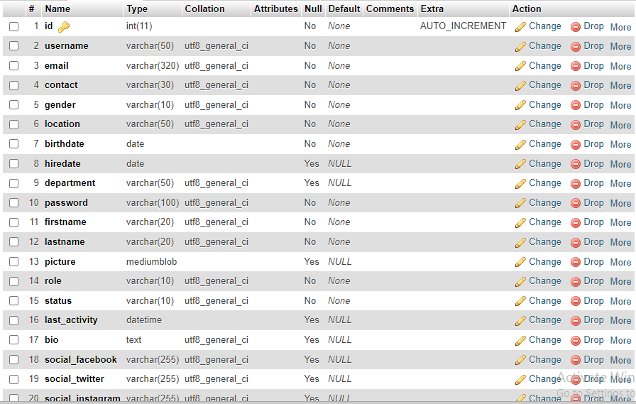**

* Stores the information of any user (client, admin, manager) => because of that not all fields are required (for example: department is not necessary for clients).

**Table 2: categories:**

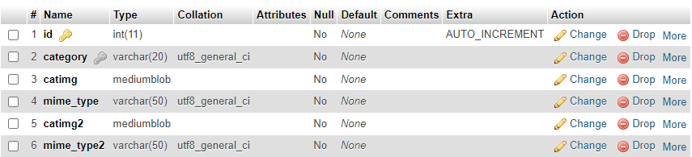

Stores category name and two images represents the category for front end needs.

**Table 3: products:**

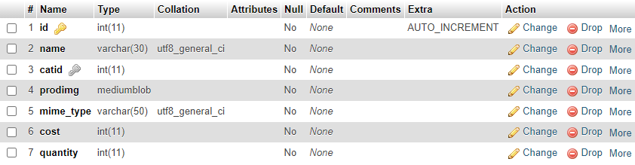

Stores information about product and the category that tis product relates to through out a foreign key from catid in this table to id in **categories** table.

**Table 4: uncompleted_orders:**

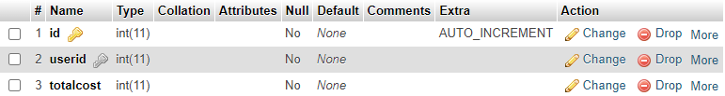

Used to store a temporary uncompleted order once the client logs in, and the products that the user want to add to his cart will be added to this order through adding it to **uncompleted_order_details** table, but it will not be stored as official order (in **orders** table) until the user fills cart required data as address and place his order, then the uncompleted order will be an official order and added with it details and cart information to **orders** and **order_details** deleted with its details and a new uncompleted order begins. **If the user logs out without placing the order it will be deleted from the database with its details (from uncompleted_orders and uncompleted_order_details table) as if he does not make shopping at all.**

**Table 5: uncompleted_order_details:**

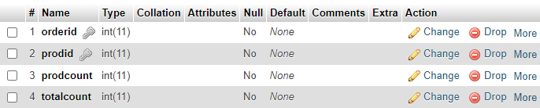

Contains products related to a specific uncompleted order, each product count, and total quantity of this product in our store (taken from **products** table to make coding easier).

**Table 6: orders:**

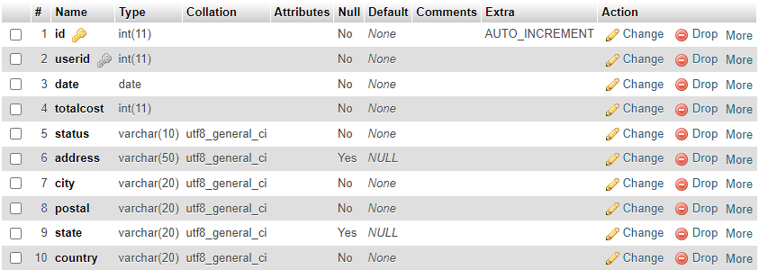

As you can see the order will be attached to the logged in user. (there is relation between **orders** and **users**).

**Table 7: order_details:**

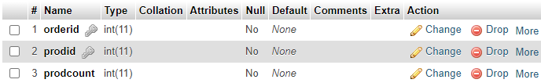

Contains products related to specific order and each product count.

**Tools used in the project:**

**1-VS CODE.**

**2-XAMPP.**

**3-Flat Icon website.**

**4-Canva Website.**

**5-AI Tools.**

**6-I might have forgotten other things.**

# **Project database UML:**

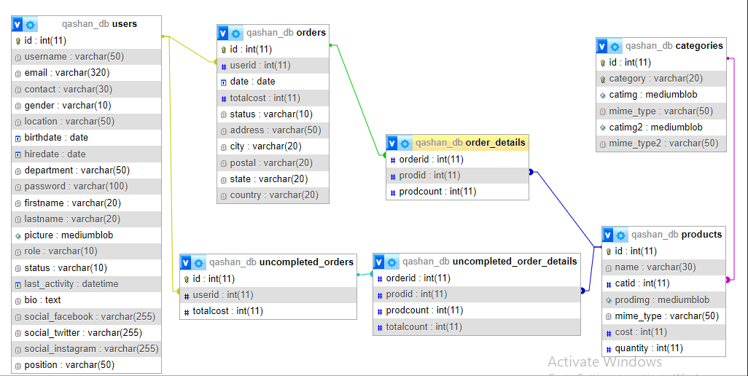

# **GUI work:**

**We have 6 main pages:**

1-Home (Welcomes the user & contains trending section and most purchased).

2-Shop (show categories & products in each category).

3-Product details page(accessed by clicking on one of the products) & Cart page(cant be accessed by not registered user).

4-Contact us page (show the location and show any notes from user).

5-Profile page.

6-Admin page and it sections.

## **Not Registered User**

Only accessible pages for a non registered user are: **Home**, **Shop**, **Contact us**, and **product details** if user clicked on any product in **Home** or **Shop** pages.

1. **Home**

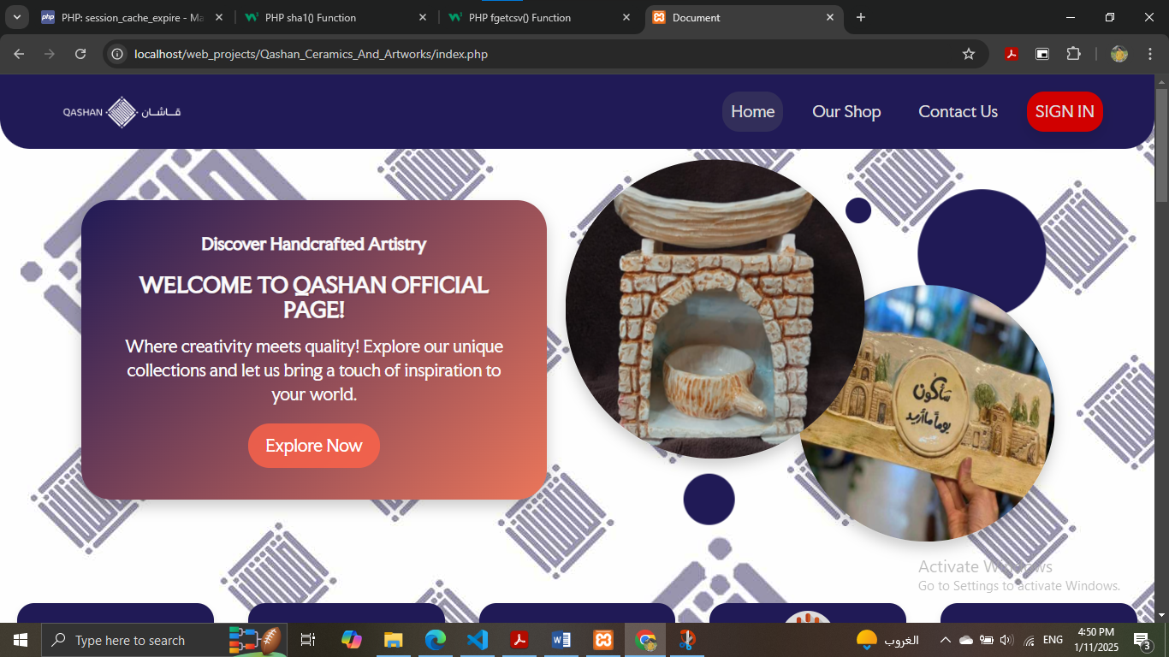

These screens from home page .

a-Sections

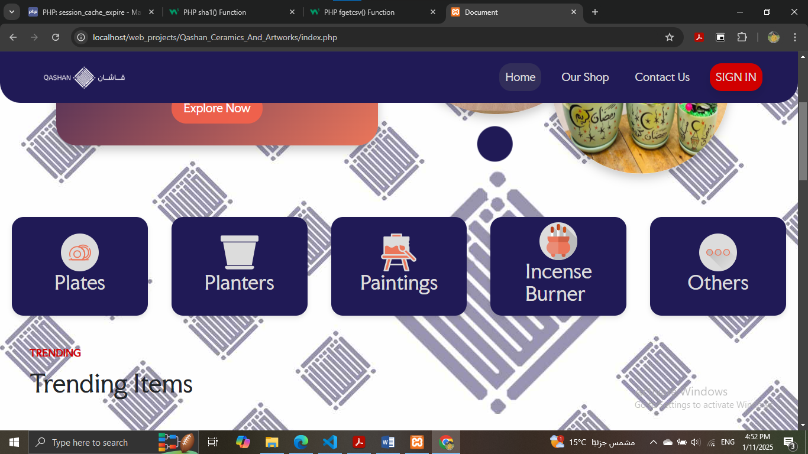  
  
b-Trending products: shows most purchased items in last 30 days only.

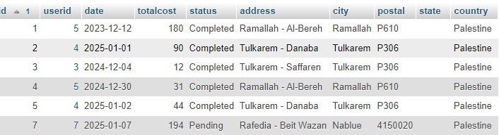

As you can see in orders table, the orders done in last 30 days are 2,4,5,7 (the gap in id because I was trying to add and delete items manualy in database at beginning of developing, and I forget to reset id to 5 before trying to add using the website).

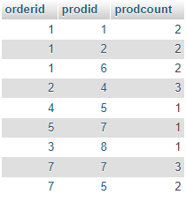Based on the order details table, products purchased in orders 2,4,5, and 7 are:

* 4: 3 items.
* 5: 3 items.
* 7: 4 items.

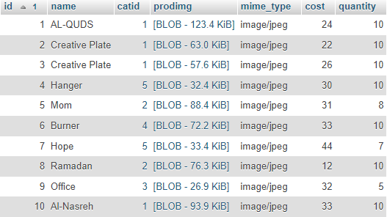

Products 4,5,7 are: Hanger, Mom, and Hope respectively, and that’s what shown in:

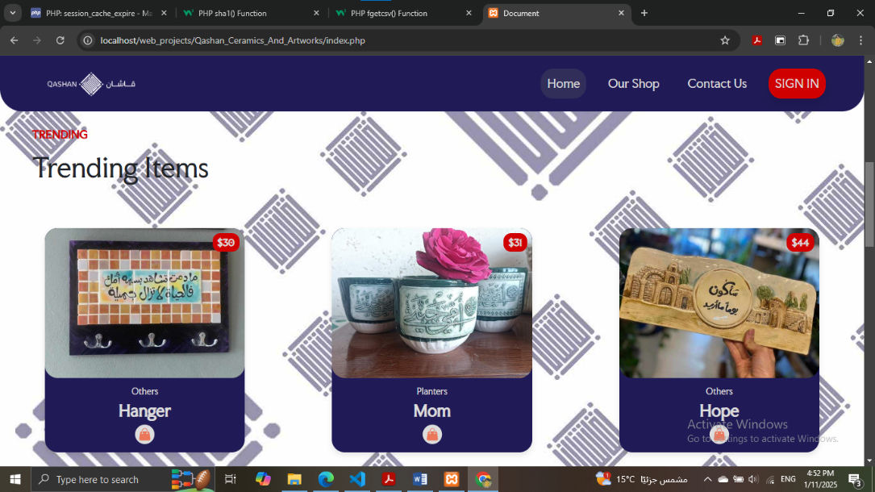

c-Most Purchased: Same idea as trending but this shows the most purchased products all time.  
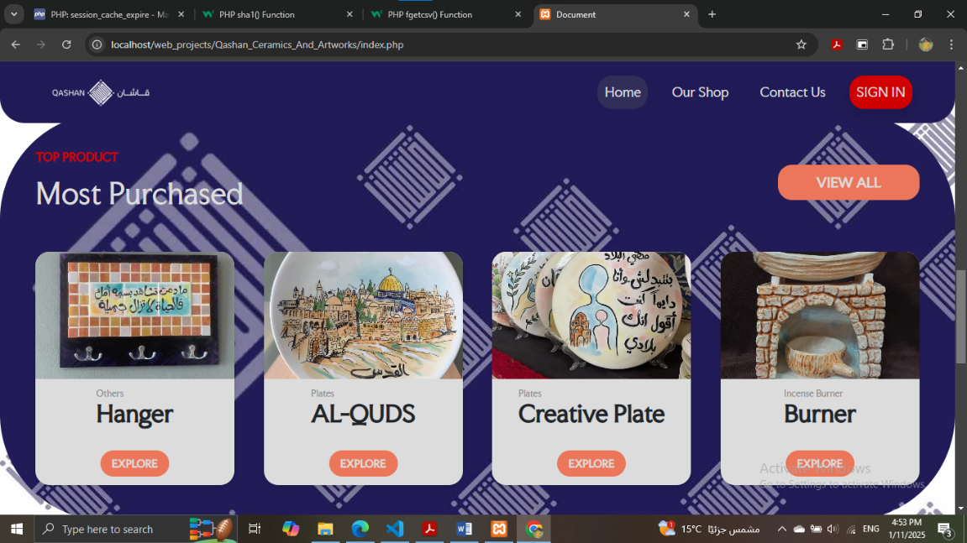

d-Extra information and fotter(this fotter for each page except admin page):

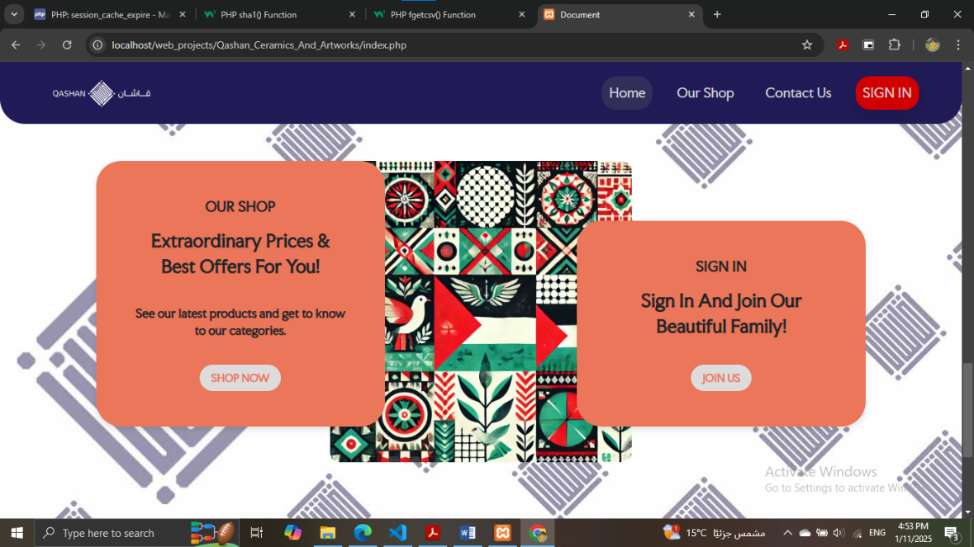

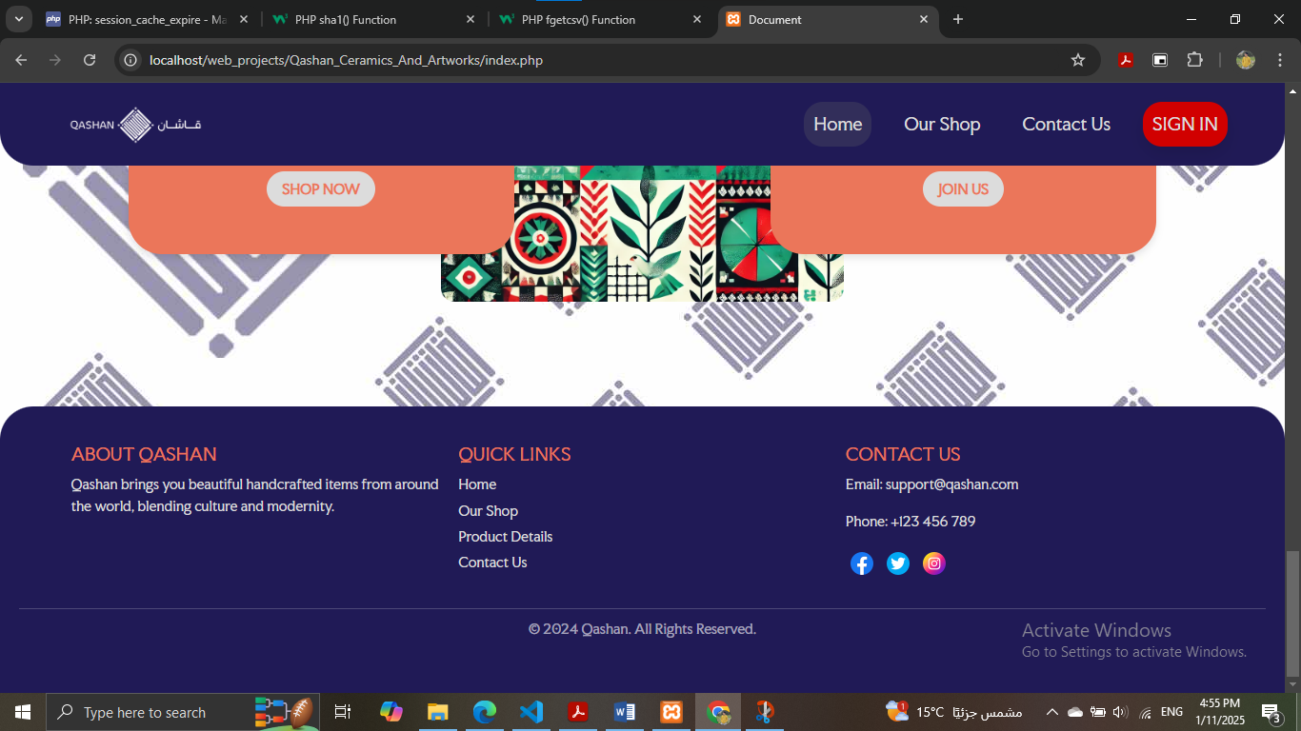

# **2-shop**

* It applies filtering for all products based on their category(done using javascript and php).
* No more 8 products occure in one page (done using javascript).

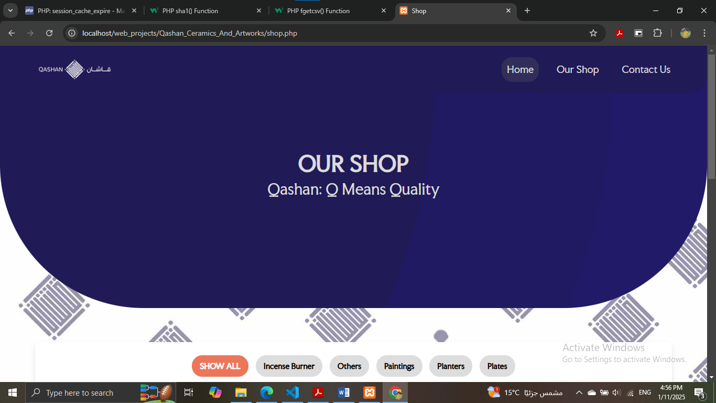

# 

# 

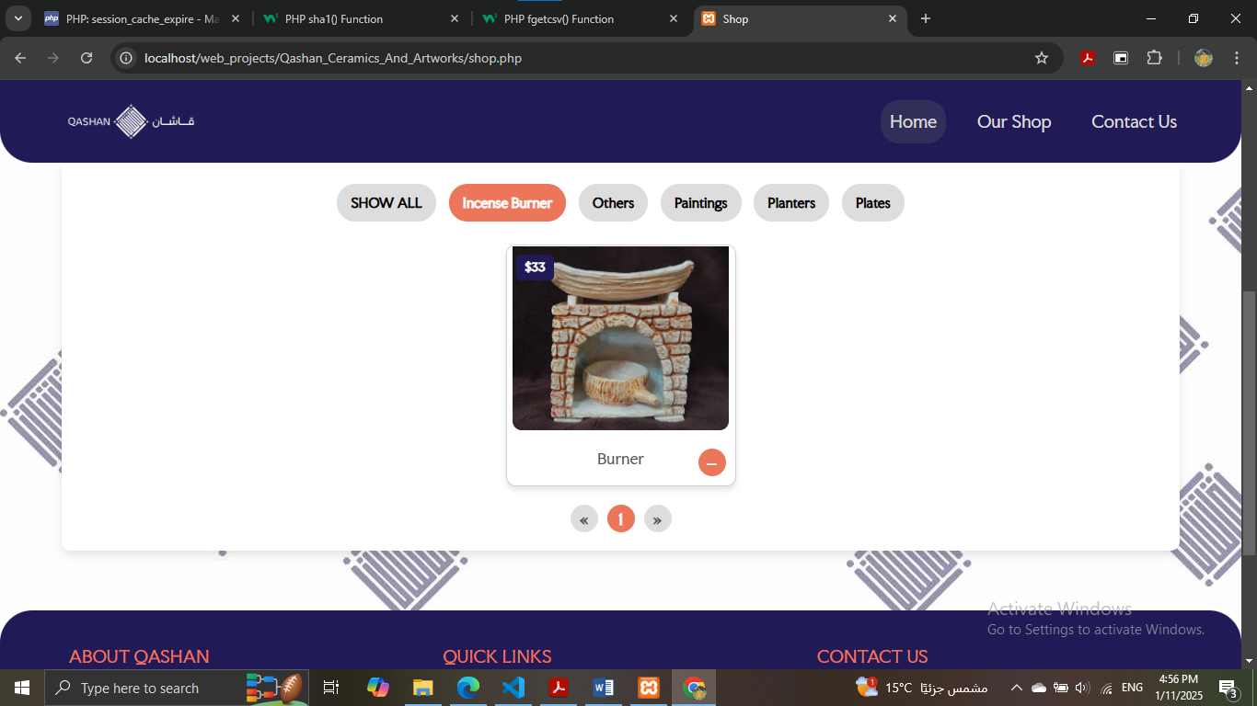

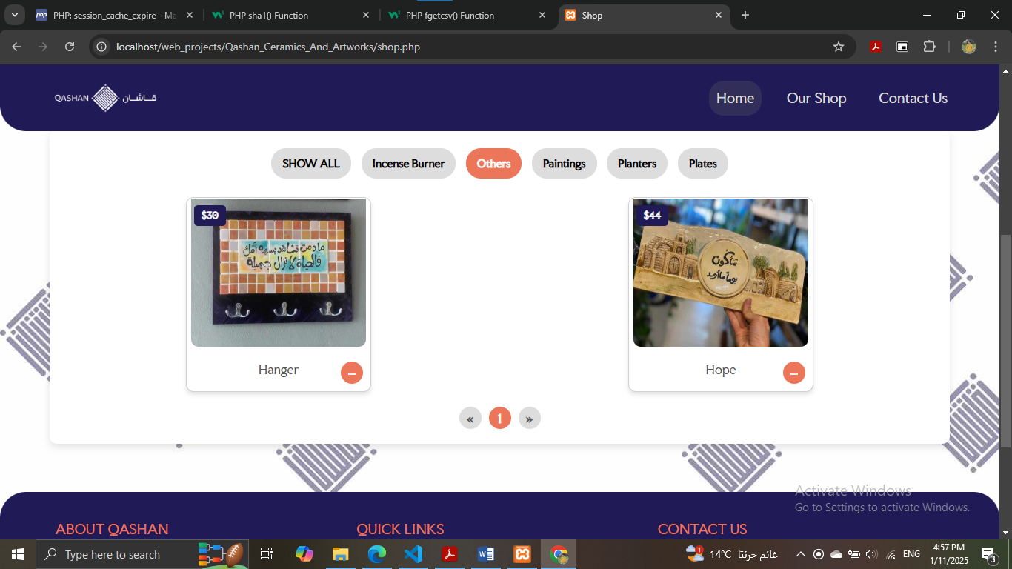

**3-Product details: Accessed on click on any product in shop or home pages.**

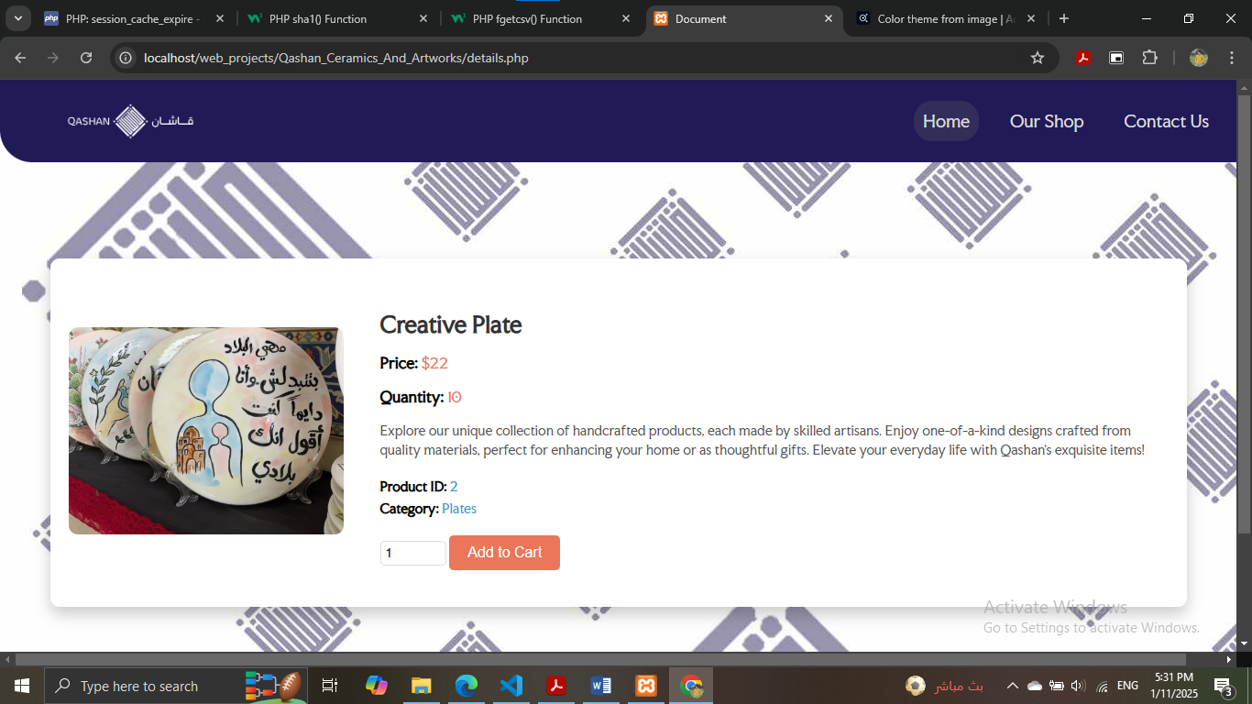

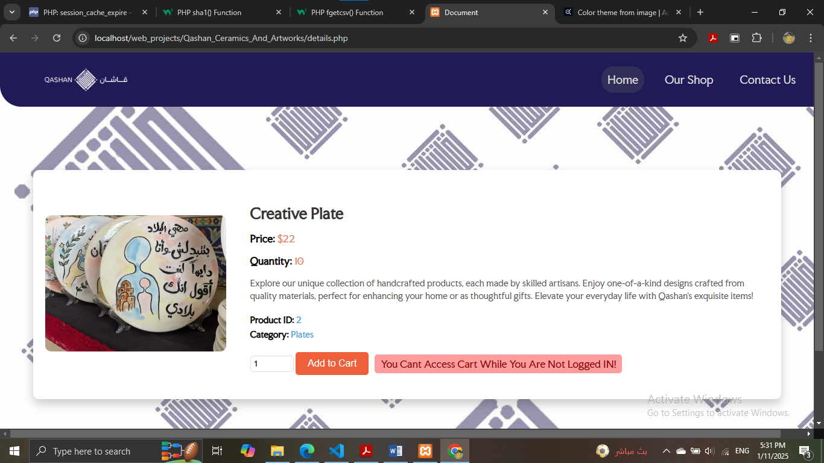**You cant access cart or add to it if you're not registered!**

**User will be redirected to home if he done that-Sessions**

# **4-contact us**

# **Login and Signup page:**

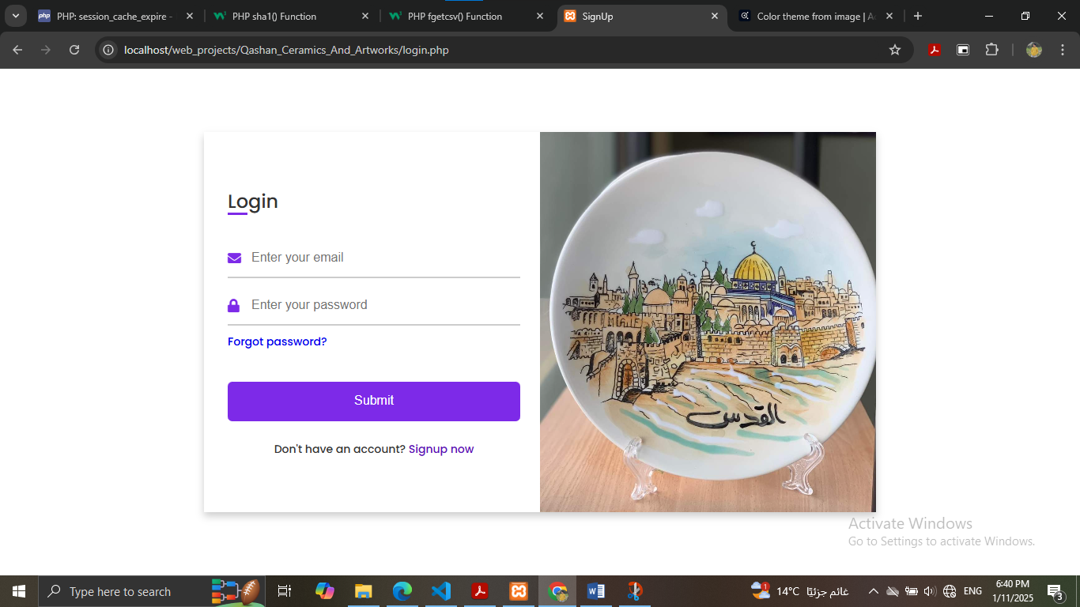

A nice motion added when moving between login and signin (like book):

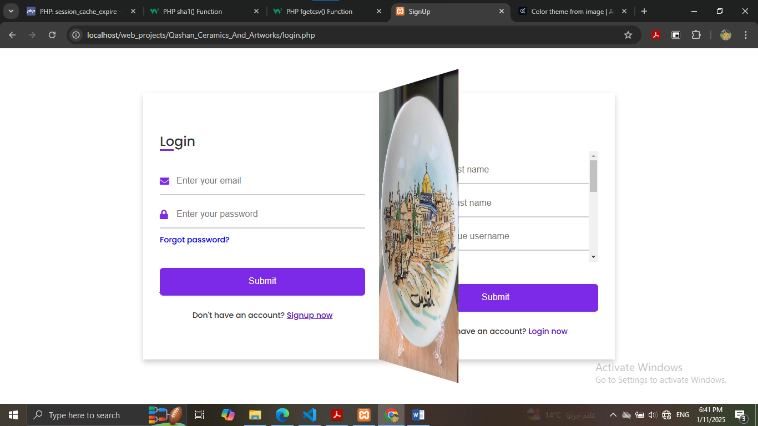

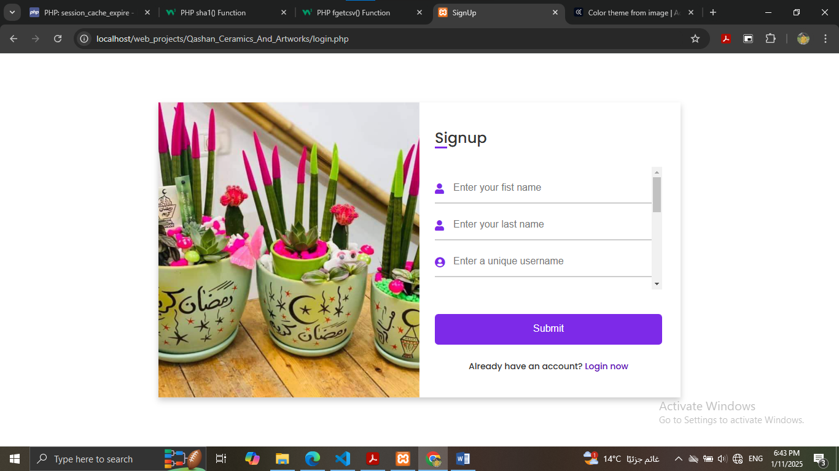

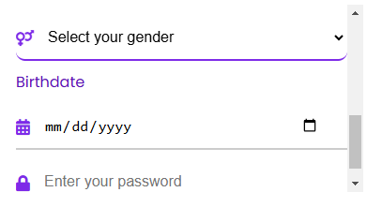

All fields are well verified an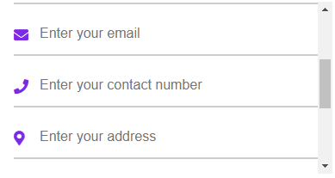d will return error message to home page if something wrong.

A success message will occure if the user logs in:

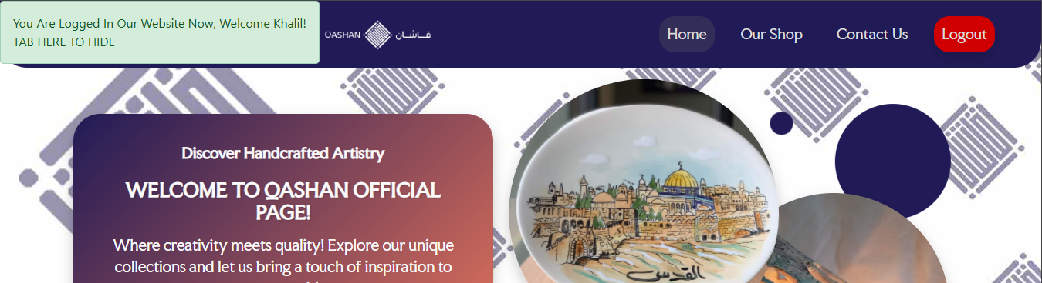

# **Registered CLIENT:**

Accessible pages for a registered CLIENT are: **Home**, **Shop**, **Contact us**, **product details** if user clicked on any product in **Home** or **Shop** pages, **cart**, **profile**.

**To make the registered user access his cart, this floating action button will be found in all his pages:  
**

**1-Home: The only change is the header:**



**2-Shop: No change.**

**3-Contact Us: No change.**

**4-Product Details: Now you can specify a quantity for the shown product and add it to cart:**

* **You cant add more than the stock quantity of the product.**
* **You cant specify a zero quantity.**
* **You cant add the same product to card twice (if you want to adjest it quantity go to cart.**

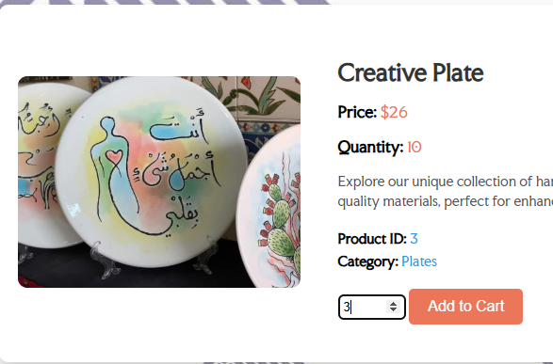

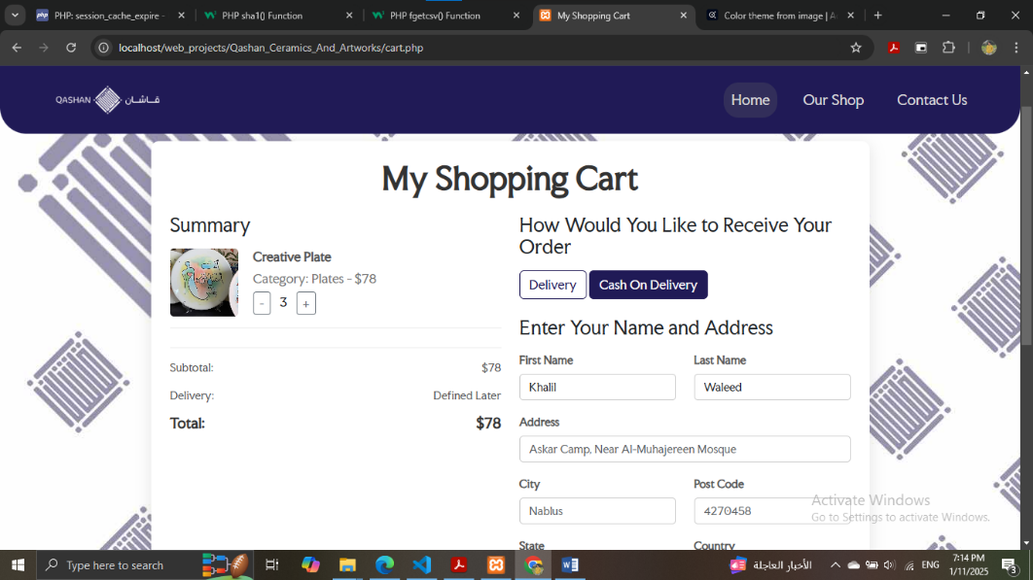

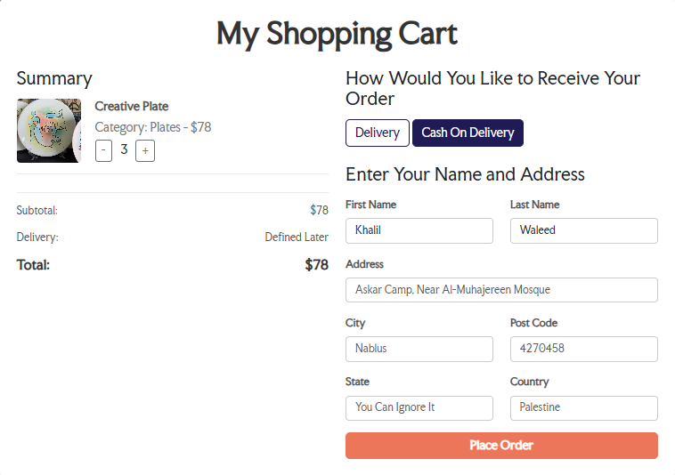

**As I said before, once the user logs in, an uncompleted order will be created to store cart items until he places the order so the information moves to the official order table, or log out and the uncompleted order removed as if it not added.**

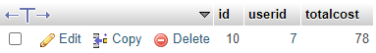 **uncompleted order.**

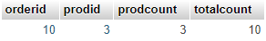**details.**

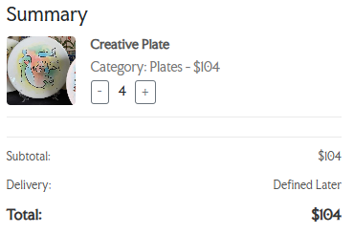

**Increase/decrease quant.**

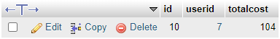 **uncompleted order.**

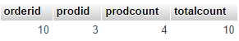 **details.**



**Product before order.**

***After Placing The Order:***

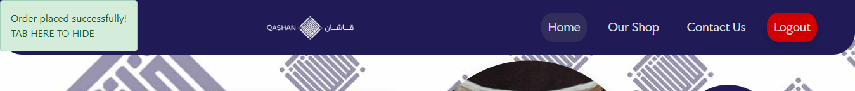

**Return to home with success message.**

**Home page will not updated now (trending and most purchased items) because this order is pending and waits admins to approve it).**

**However lets see the changes:**

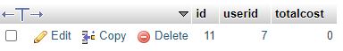**uncompleted orders.  
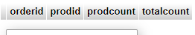details.**

**Previous uncompleted order is deleted and and a new one starts.**



**New pending order added.**

**details of it (ordered,prodid,quantity).**



**Stock quantity updated.**

**5-Profile:**

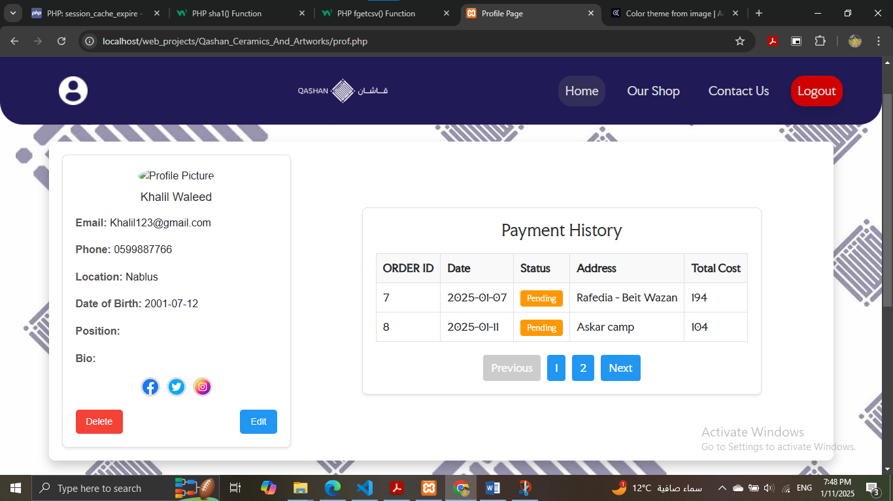

**As you can see, there is payment history, and the last payment is added.**

# **Registered Admin:**

If you try to access admin page without permission and login you it will turn you back to home page as unregistered user.

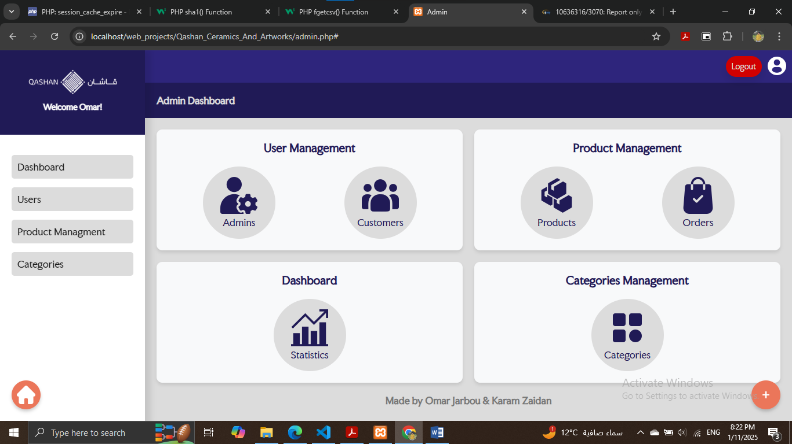

# **Admin Sections.**

**a-Categories:**

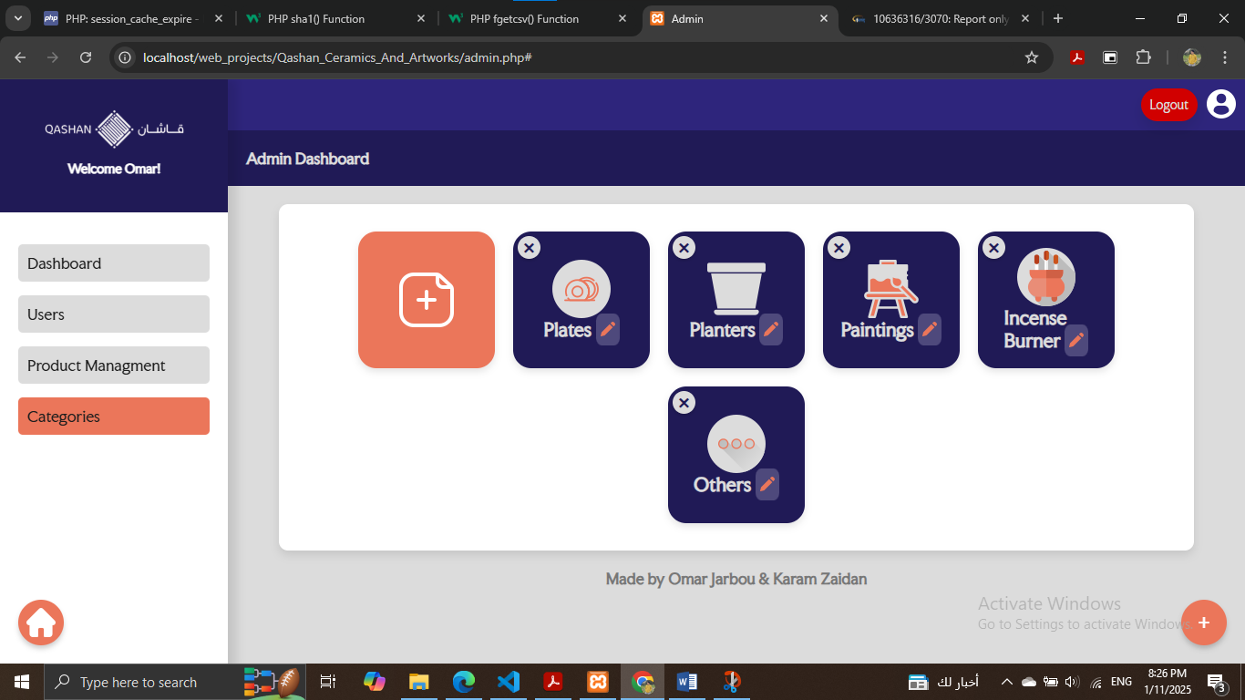

**You can add/edit or delete a category**

**Add:**

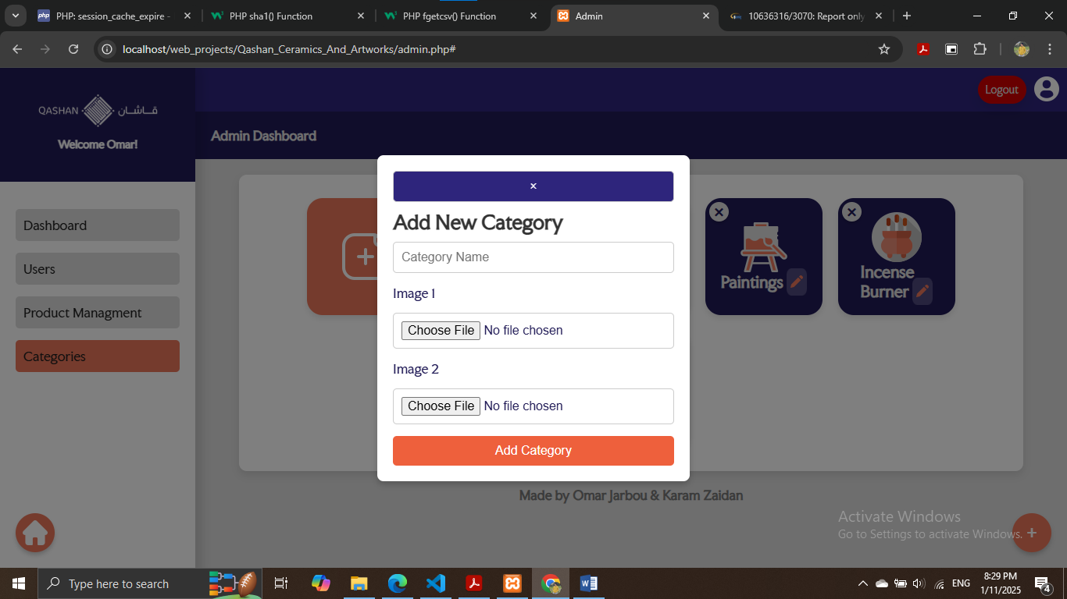

**You have to add two images that represents the category for front end needs (natural case and hover case).**

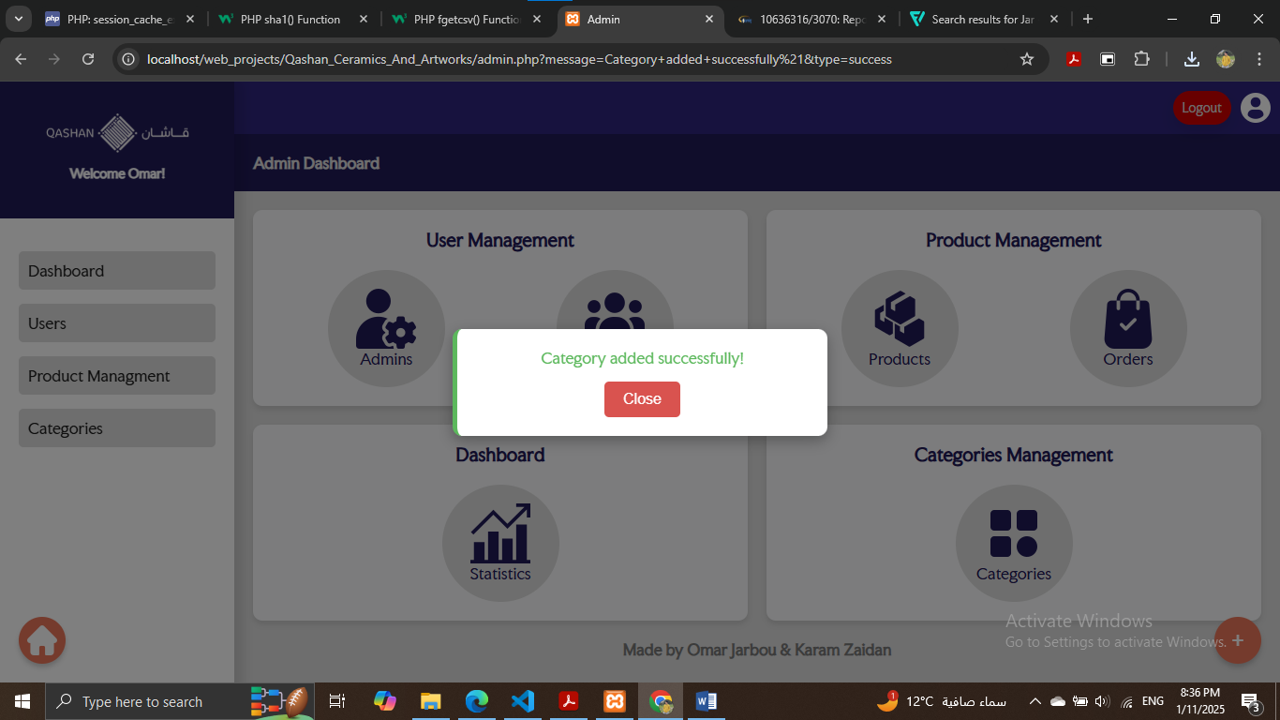

**Successful addition**

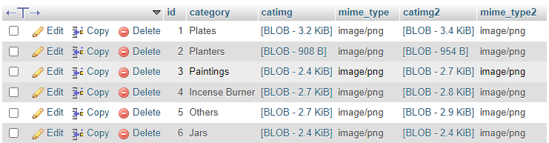

**Effect on Home and Shop**

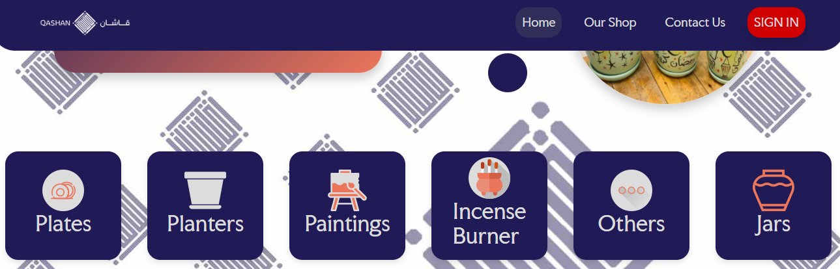



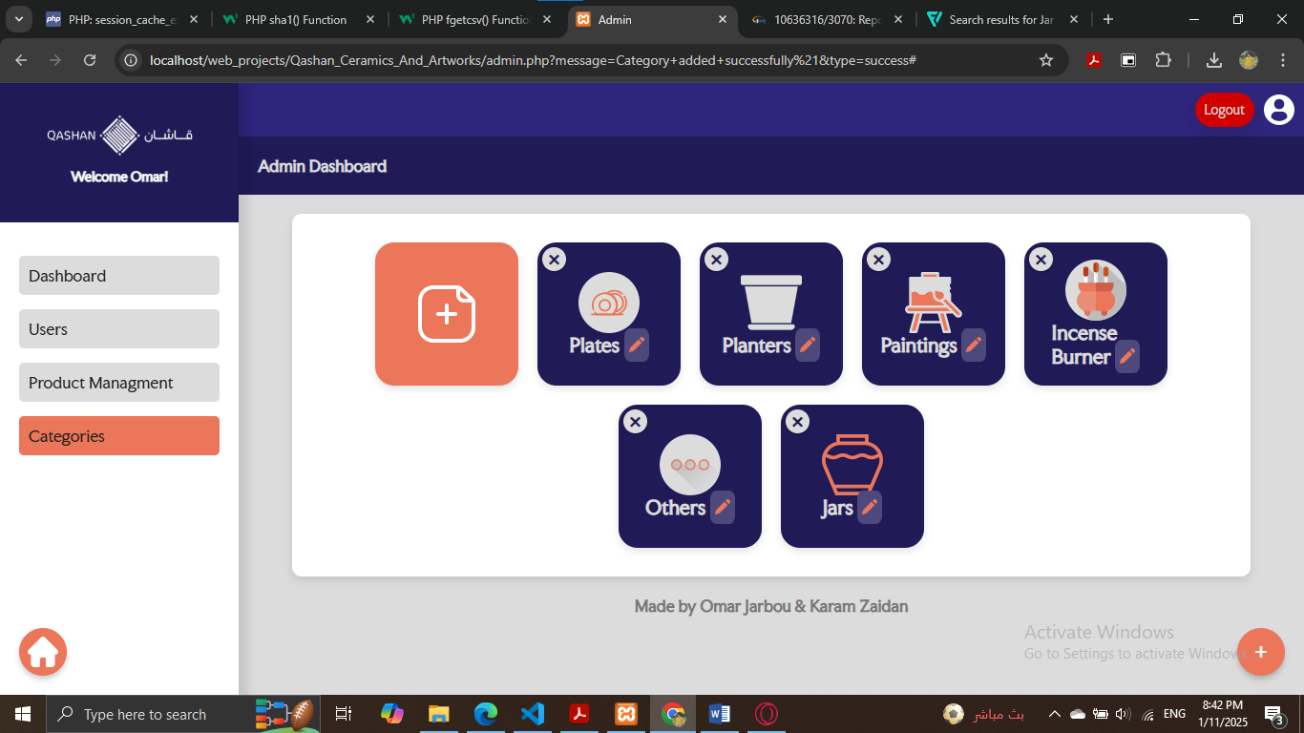

**Edit:**

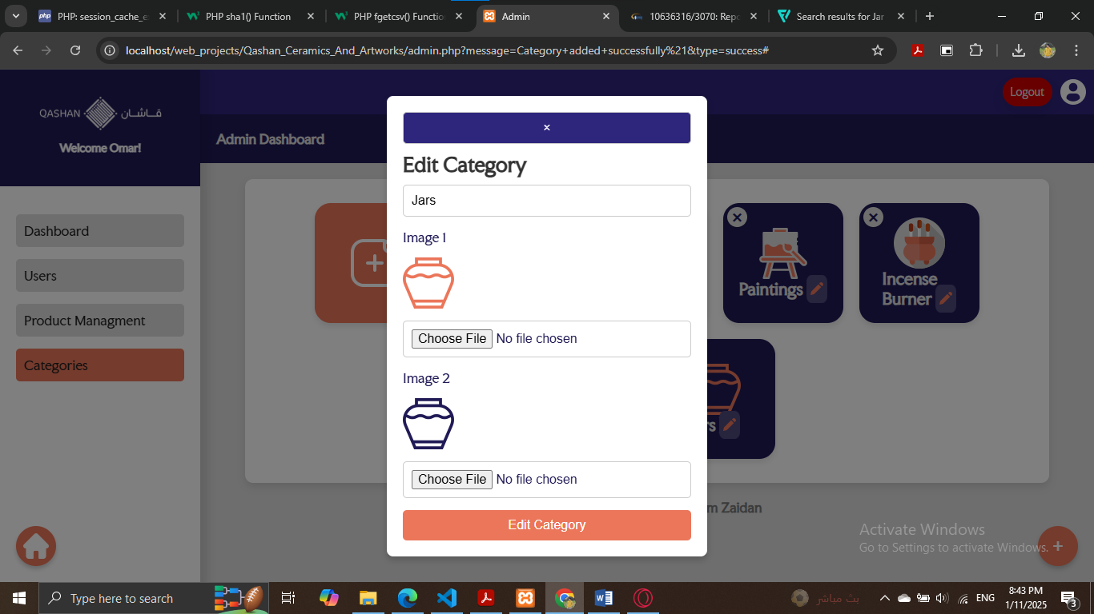

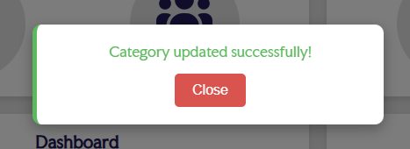



**Delete:**

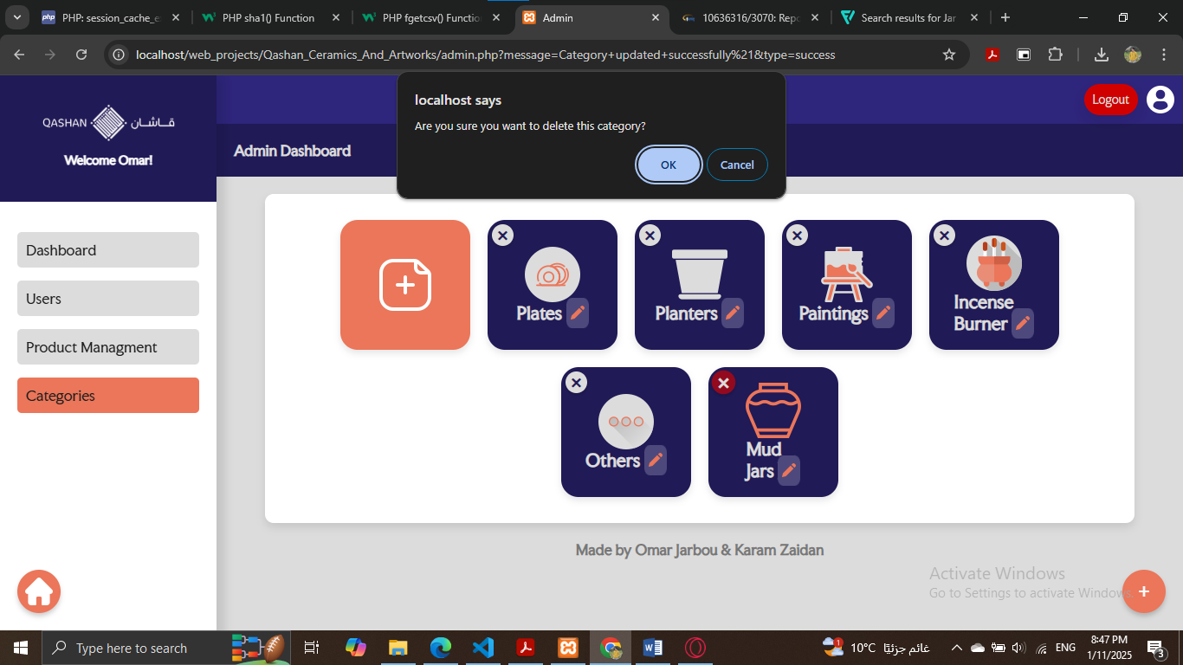



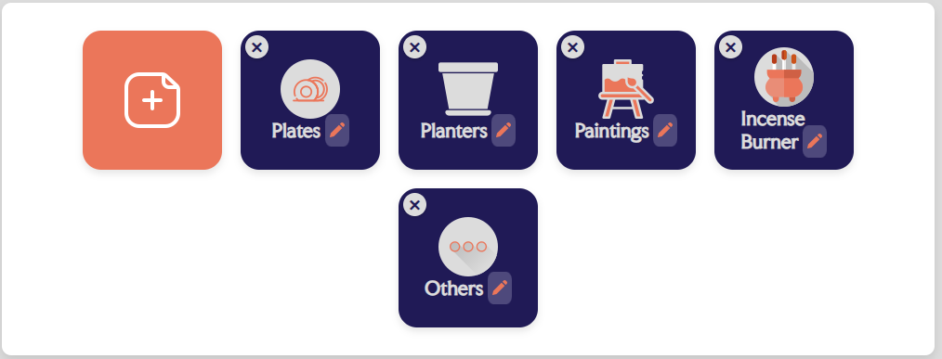

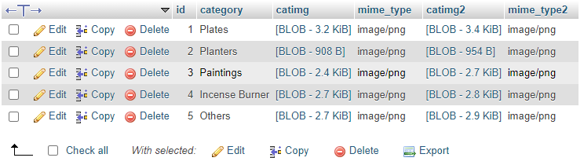

**b-Products Management:**The front of it is same as shop front, but it has add blocks and delete/edit buttons for each product card.

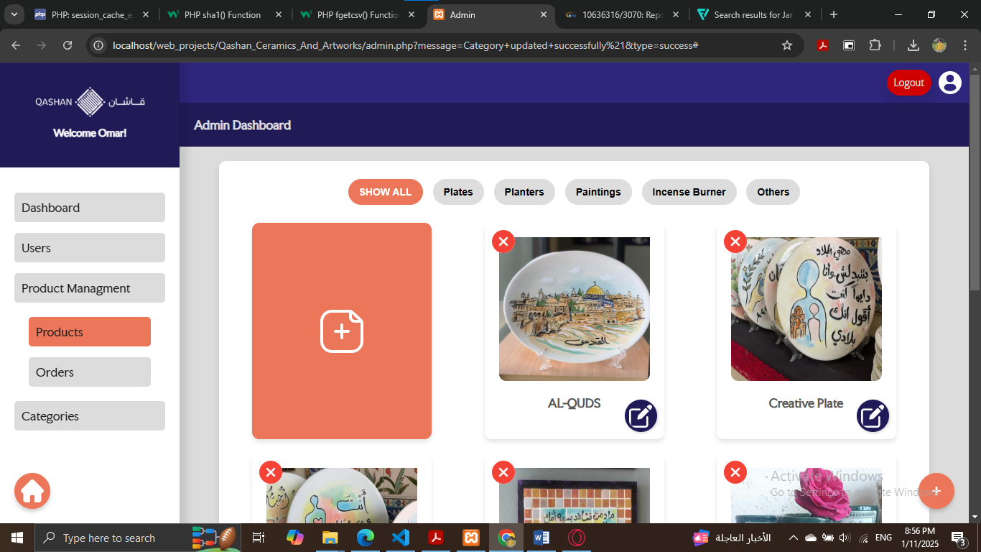

**All delete, edit, and add operations are the same as category operations, but the difference is:**

**-Add a product will reflect on shop page & products management (since both have the same design and backend) and add it in show all section and under it category section.**

**I will show you only front of them.**

**Add:**

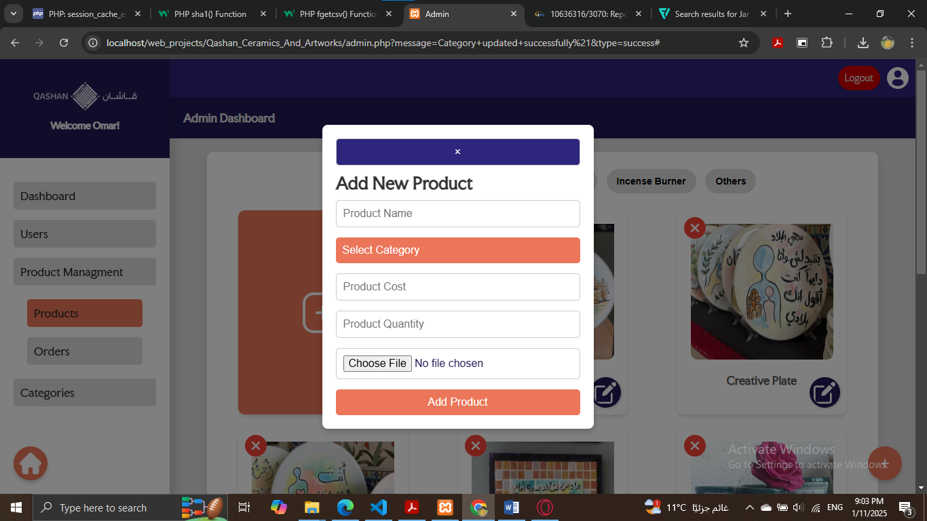

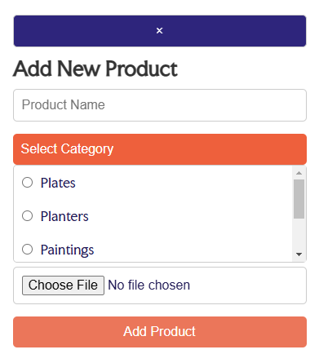

**Edit:**

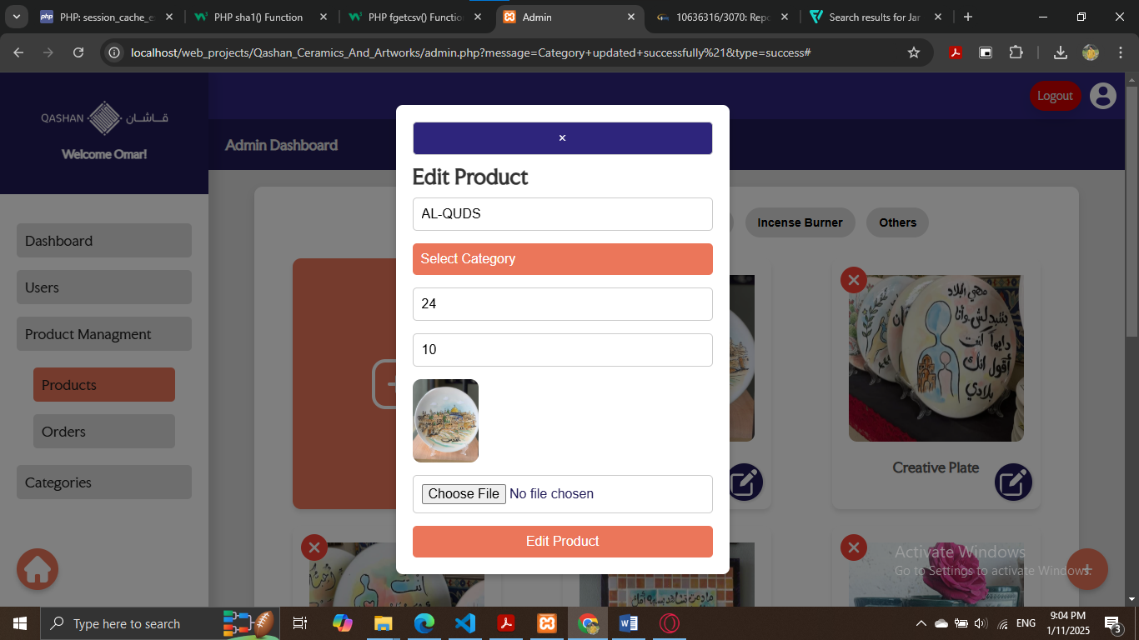

**Delete:**

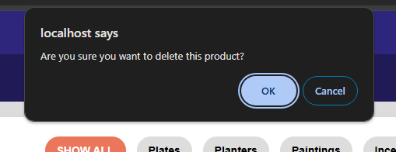

**Important Note: In all tables, if it increased than 10 rows it will make another pages (tables) and you can move between them using pagination.**

**c-Orders Management:**

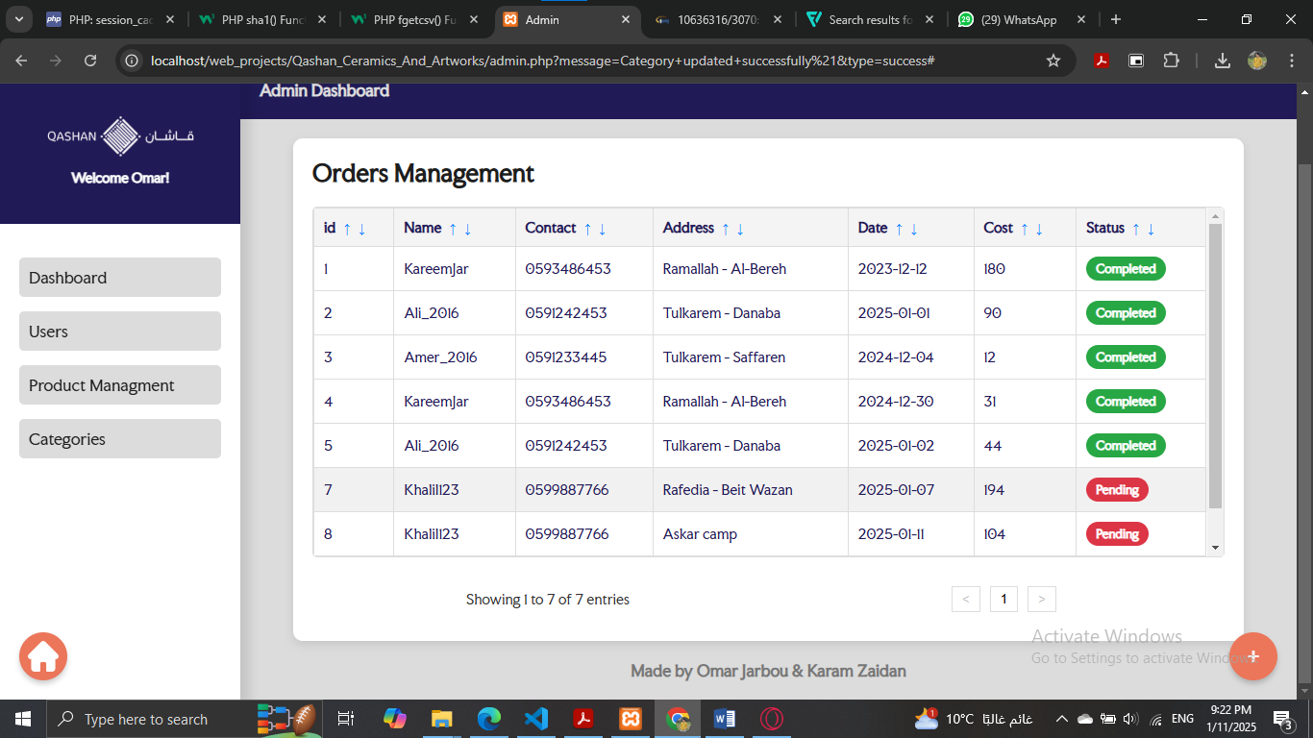

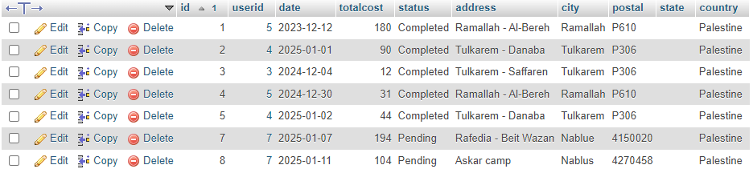

**For each completed order you can do the following:**

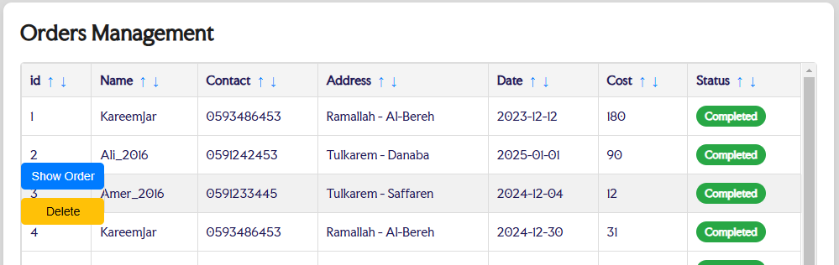

**For each pending order you can do the following:**

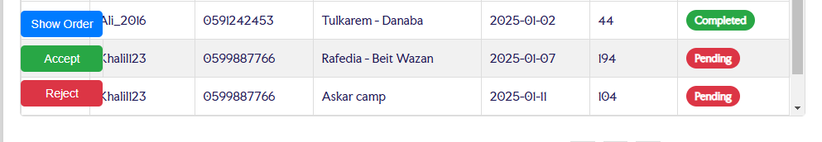

**Important Note: Admins and Users tables are updated every 5 seconds to keep traking the status (status is not implemented yet – it will be improved later)**

**d-Admins Management: Should be only for Managers but will be improved later.**

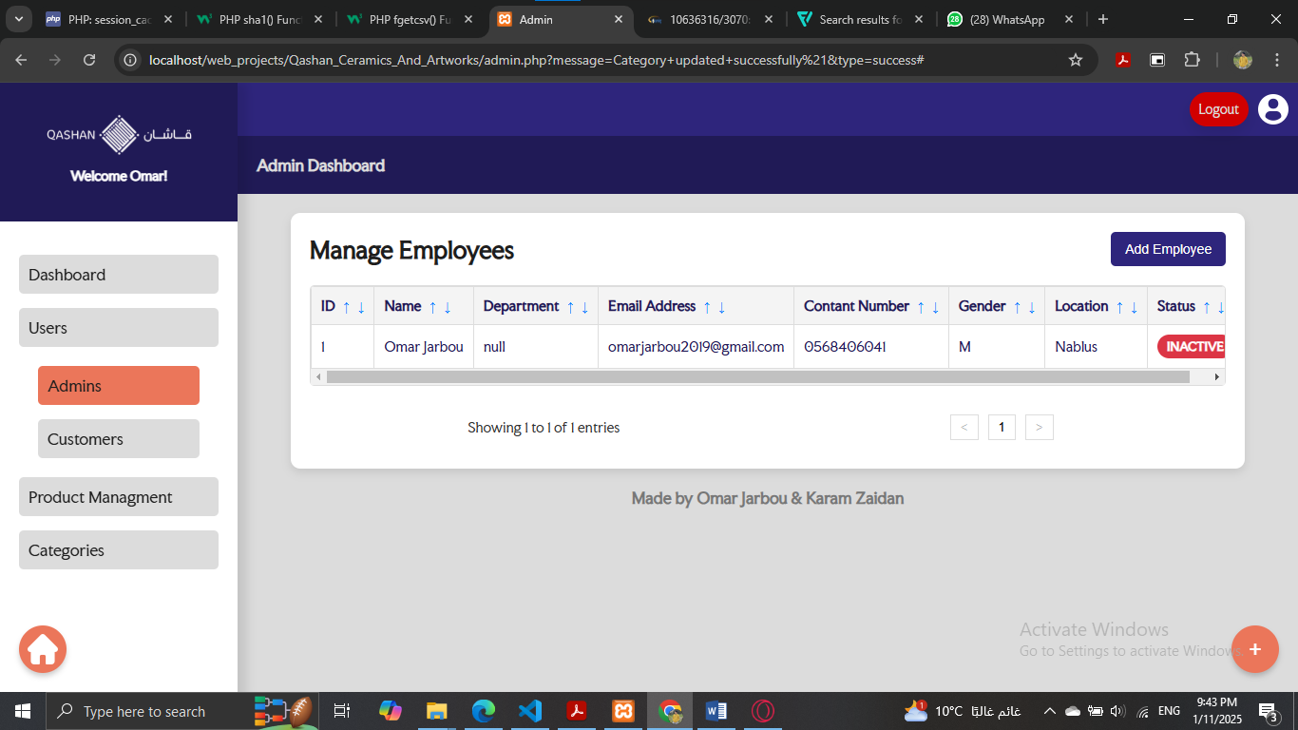

**Operations can done (Add Employee from clients & Fire Emp):**

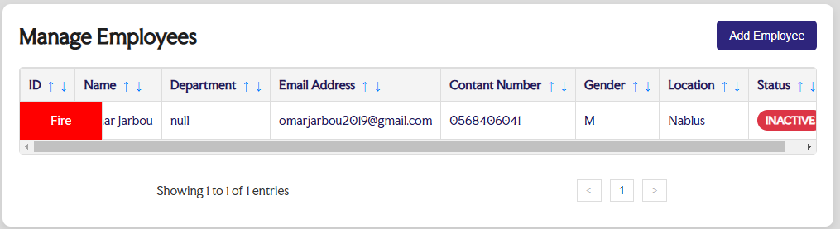

**e-Users Management:**

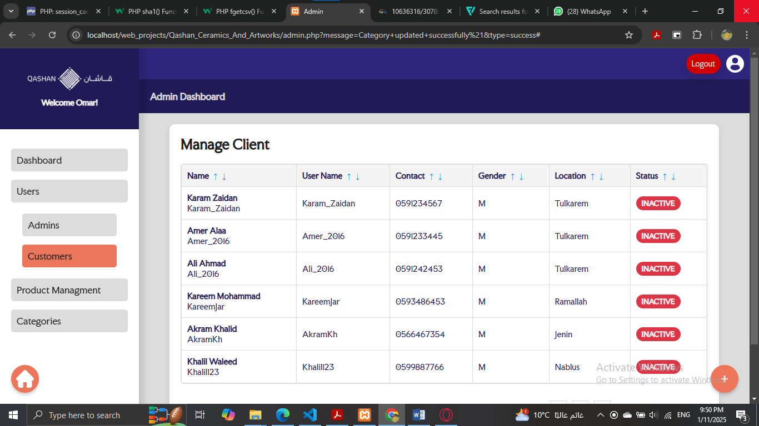

**Operations can done (Block/Remove Client & Hire Client):**

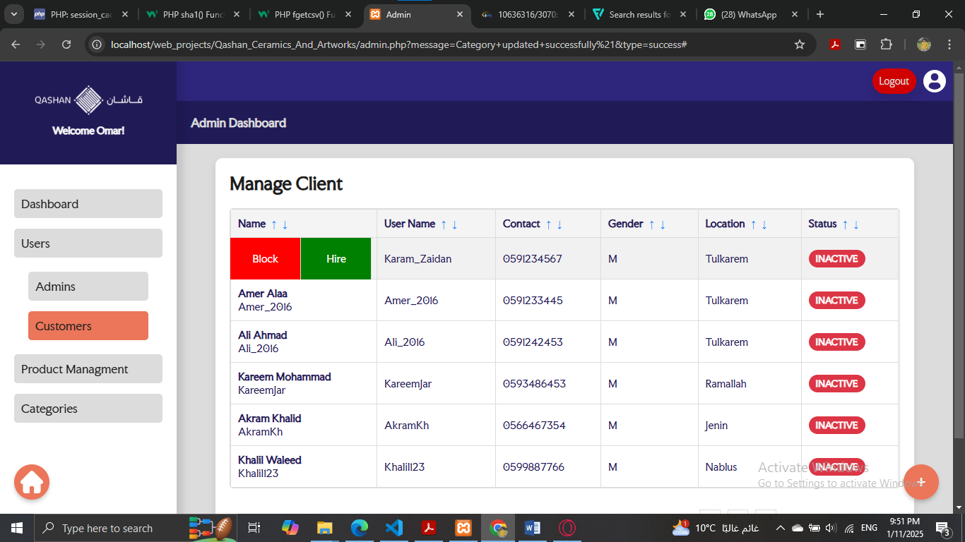

**f-Statistics: The functionality of it elements are implemented but not connected with database yet (it will be improved later).**

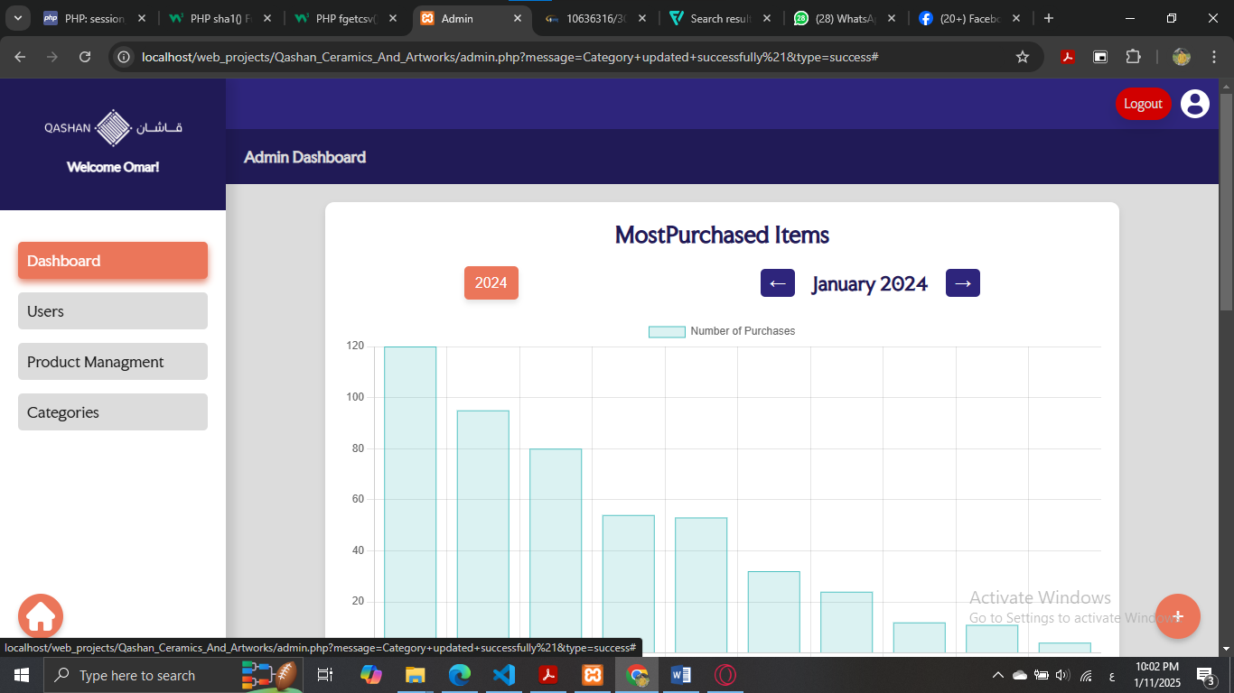

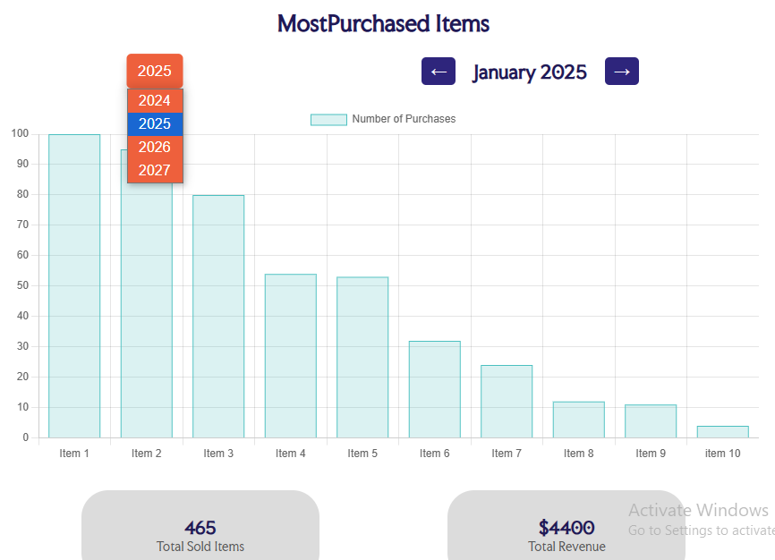

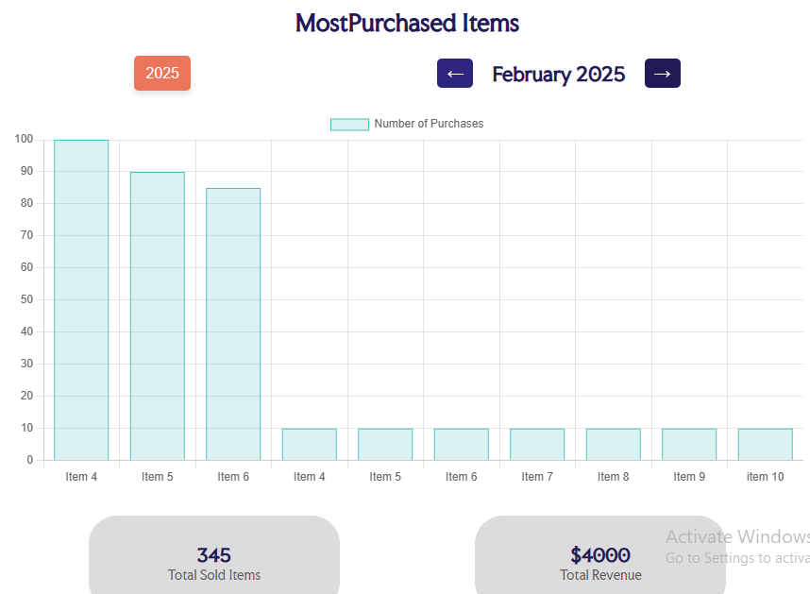

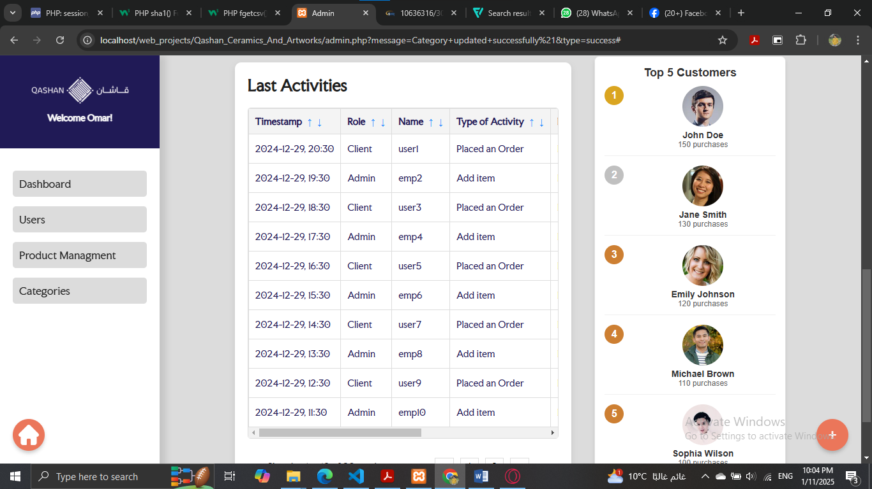

**Conclusion:**

The web user can get to know all the sections in Qashan in a very smooth way.

He can navigate the catalog to reach the section to communicate with the officials and management through the messaging system.

It includes a secure user account system, and the platform gives priority to privacy, security and maintaining the confidentiality of users.

Qashan does not only display its products for sale, but also provides many services available in the workplace, which enables the user to see what is new in Qashan in an easy way.

The project is equipped to accommodate a large number of users, so that it is ready for any future growth.

# **References:**

1. Web course by Dr.Sufyan Samara.
2. PHP documentation: [Home | phpDocumentor](https://phpdoc.org/)
3. w3schools: [W3Schools Online Web Tutorials](https://www.w3schools.com/) & other similer websites.
4. Youtube: [Abdelrahman Gamal - YouTube](https://www.youtube.com/@AbdelrahmanGamal)